ALY6030 - Data Warehousing and SQL

CRN: 71719

Module 1 Assignment

By Karan Kaushal Daiya

NUID: 001083274

Introduction:

In this assignment we will see how to install MYSQL workbench and server. Further in this assignment, we will try to answer some questions by SQL queries. For this, we will use “movies” dataset which is in .csv format and have some attributes like films, leading actor, leading actress and many more.

**Steps and Explanation:**

**PART 1:** Installing MySQL Server for macOS

First go to <https://dev.mysql.com/downloads/mysql/> to download MySQL server. By clicking on the above link, will show the below window.

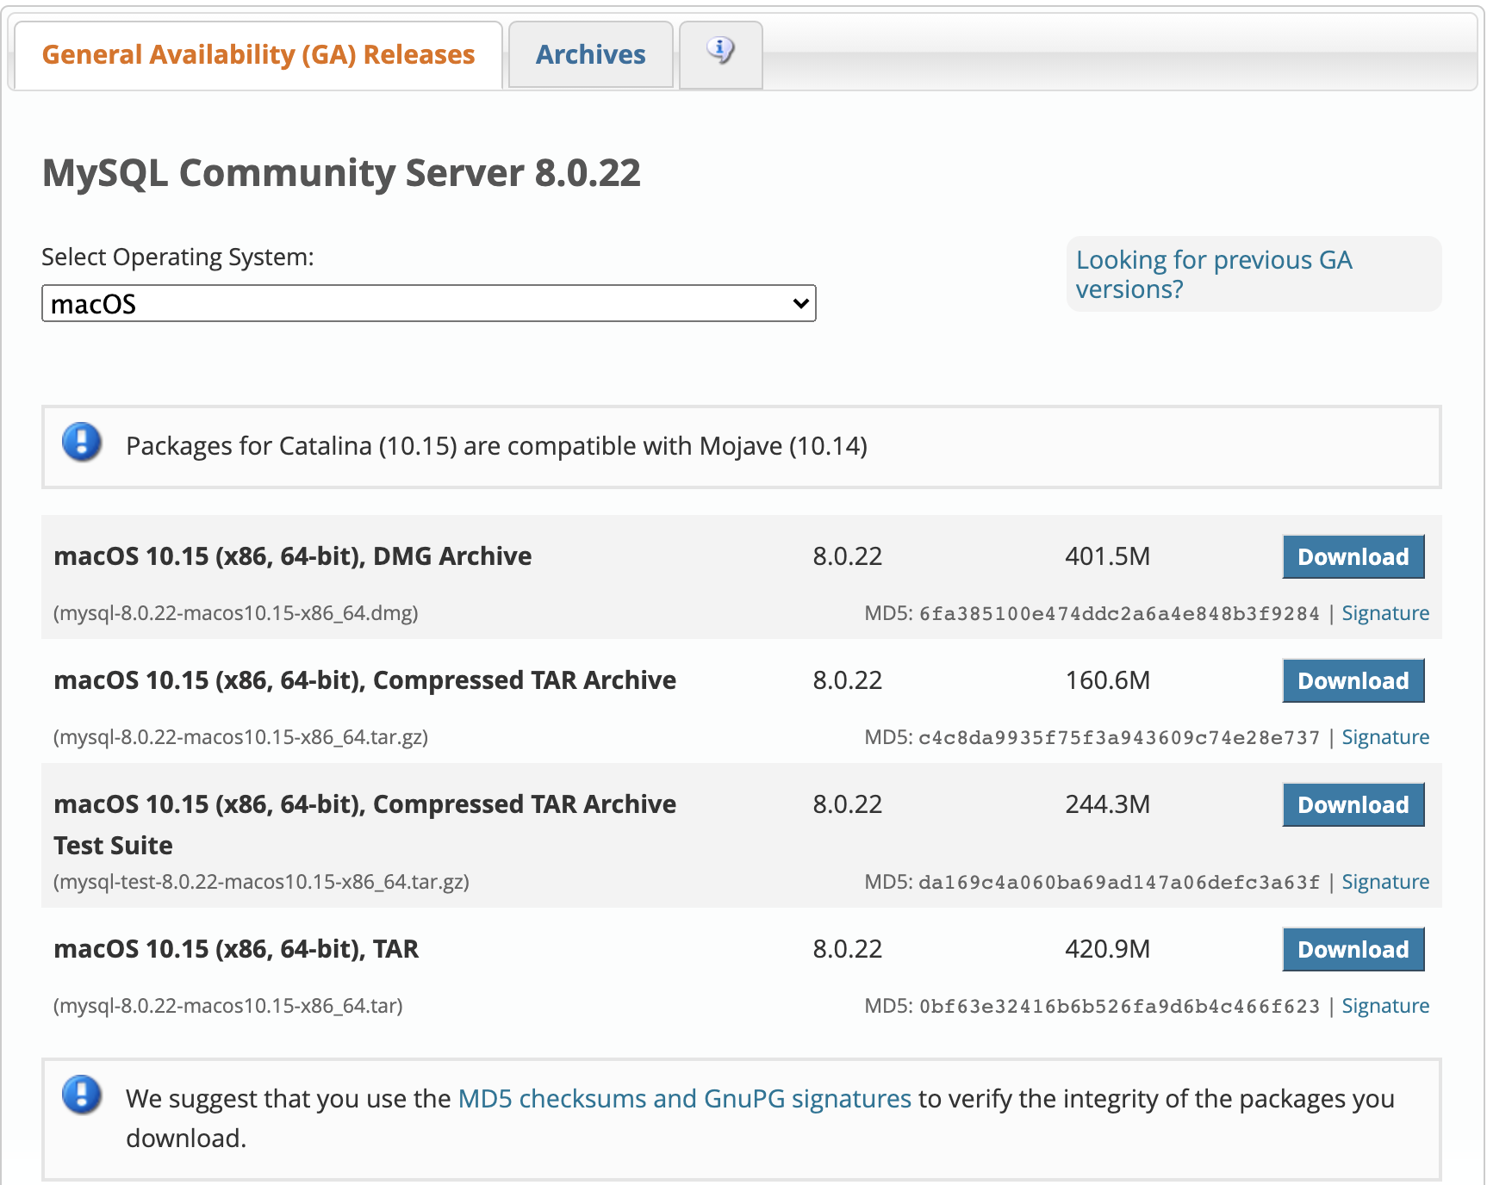

Choose the appropriate download option according to your operating system. Here, I am using macOS so I will download the .dmg file i.e. 401.5Mb as shown in the picture. Once it is downloaded, run the file and it will pop the below window.

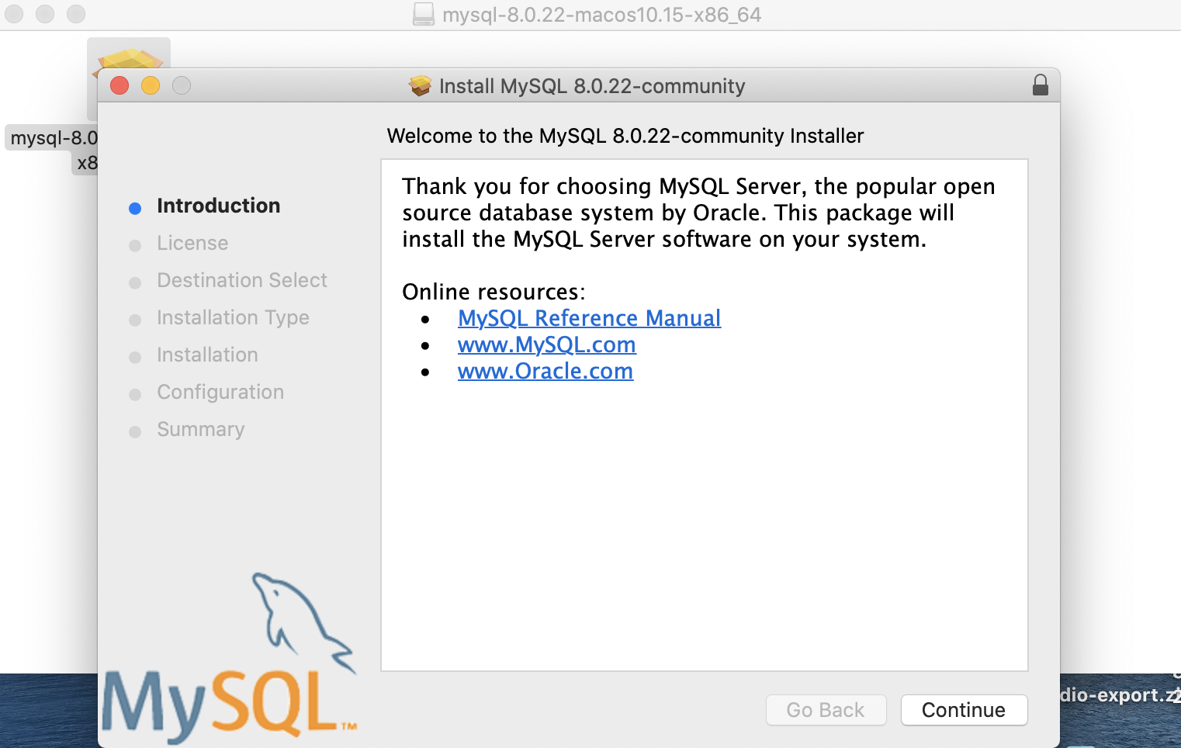

Click “Continue” to give the access for the following online resources. Further, click continue to accept the user’s license and agreements.

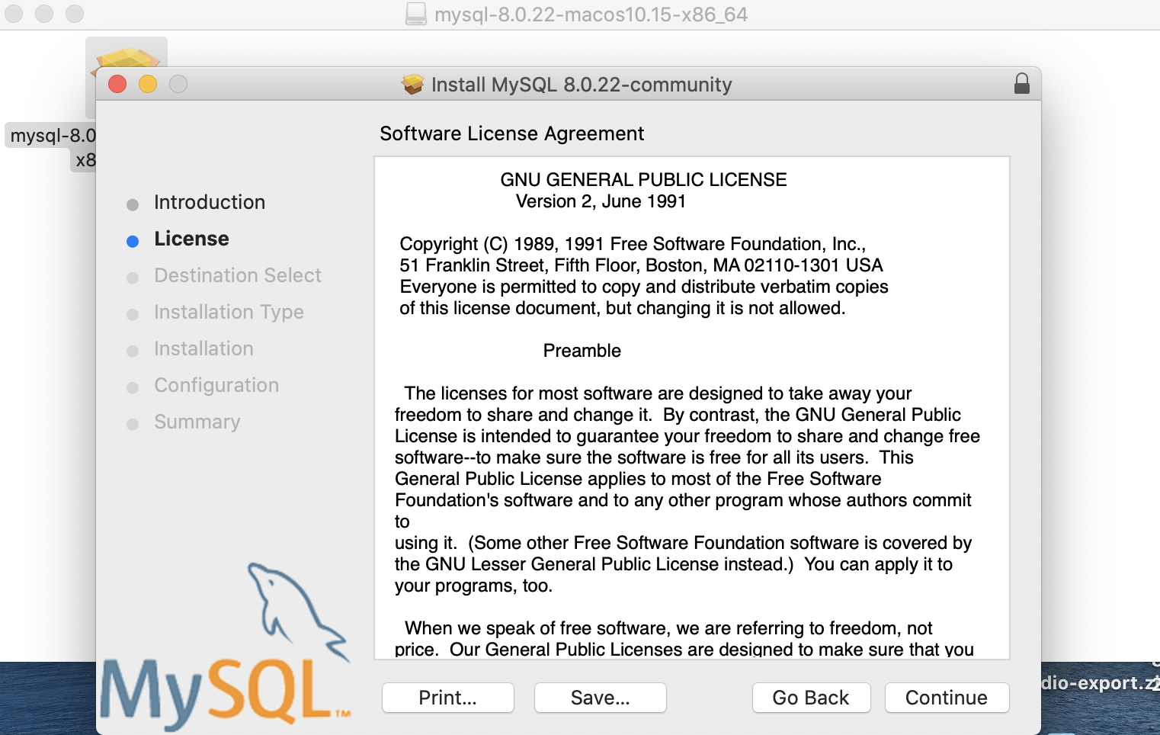

Set a reasonable password for the MySQL server and press Finish.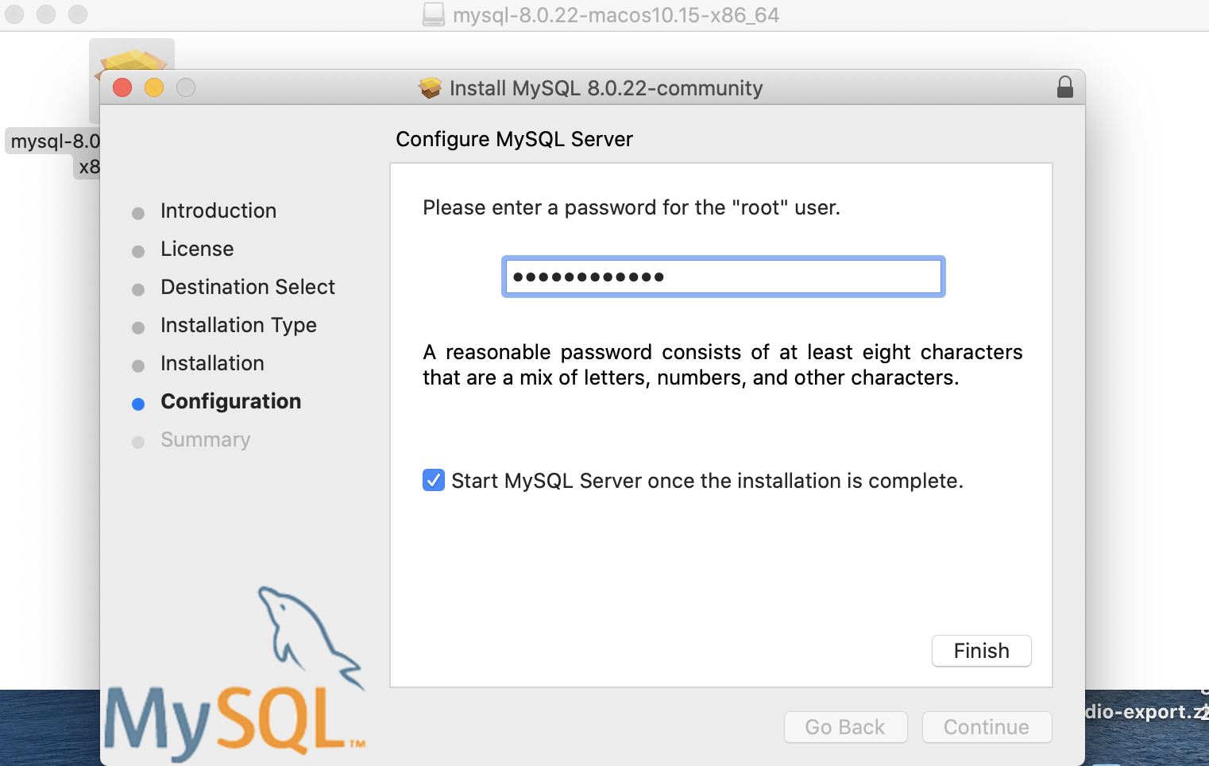

This will successfully install MySQL server to your desired location.

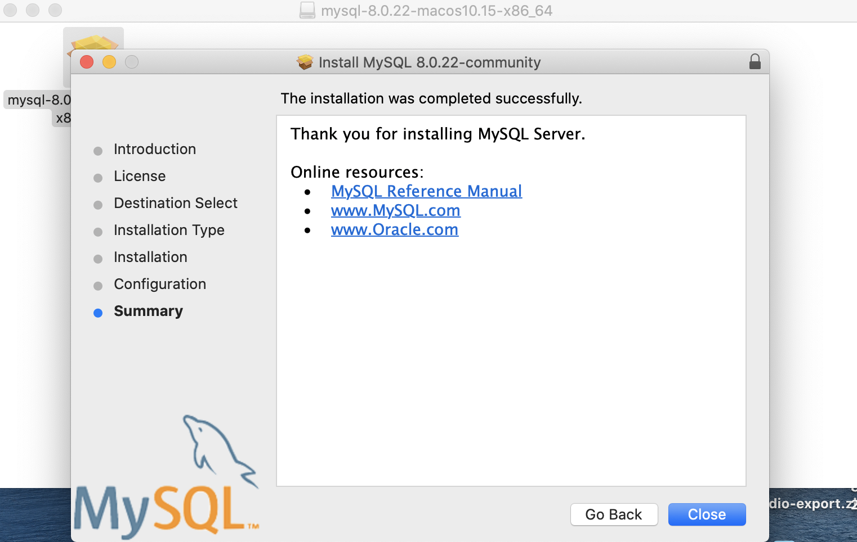

**PART 2:** Installing MySQL Workbench for macOS

Click on the following link to install MySQL Workbench,

<https://dev.mysql.com/downloads/workbench/>

For Windows users, you can directly select “developer default” option from your server installer which will initiate the installation of MySQL workbench too but being a mac user, we have to download both server and workbench separately.

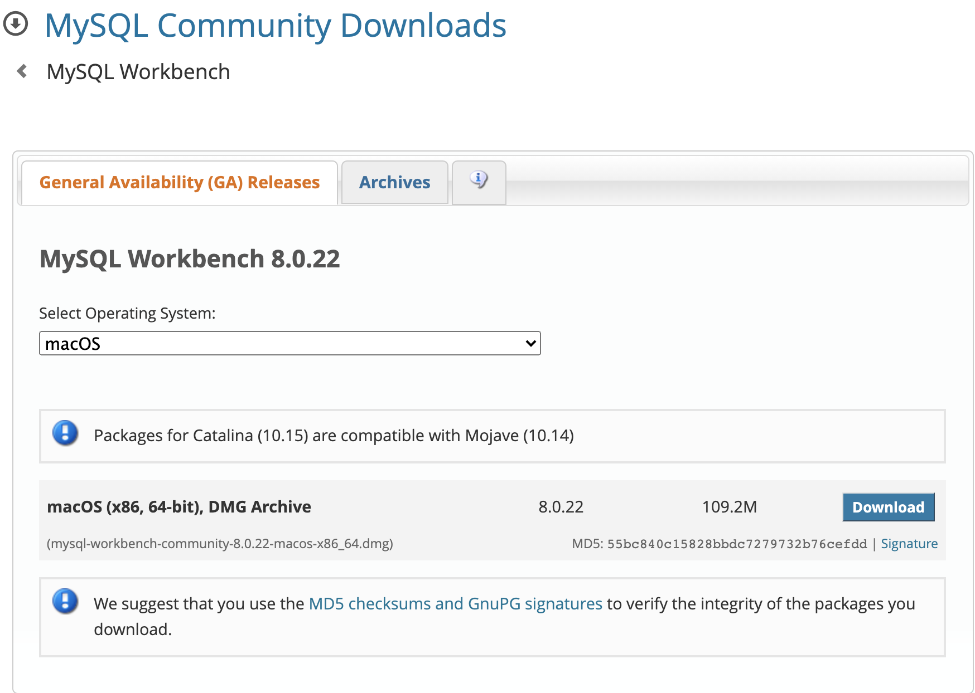

Click on the Download button to start your download.

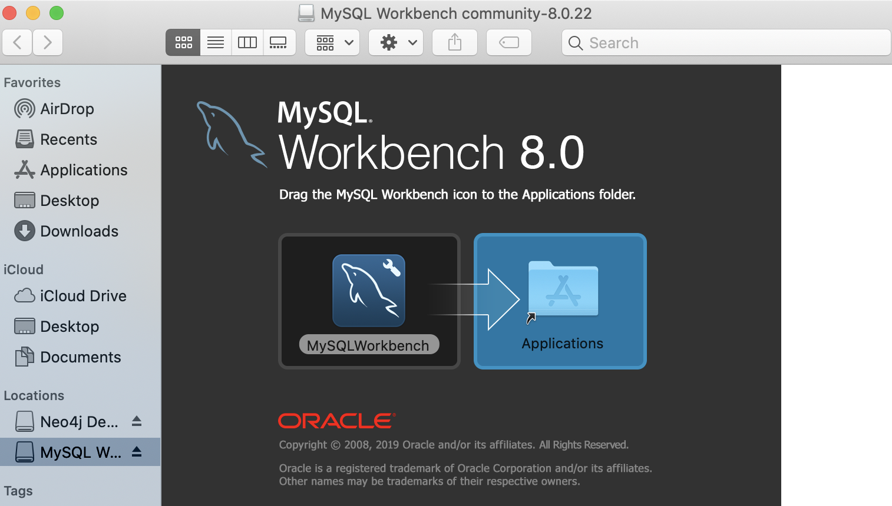

After running the downloaded file, it will ask to move the MySQL Workbench icon to the Applications folder doing so will add this workbench in your launchpad.

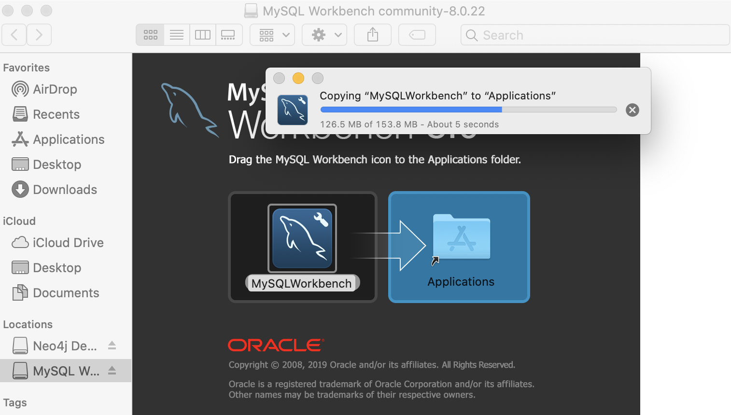

**PART 3:**

Open MySQL Workbench from your applications and click on the localhost server which will ask for your root password that you entered while installing MySQL Server. After entering the password, it will pop the below screen. Here, the server port number is 3306.

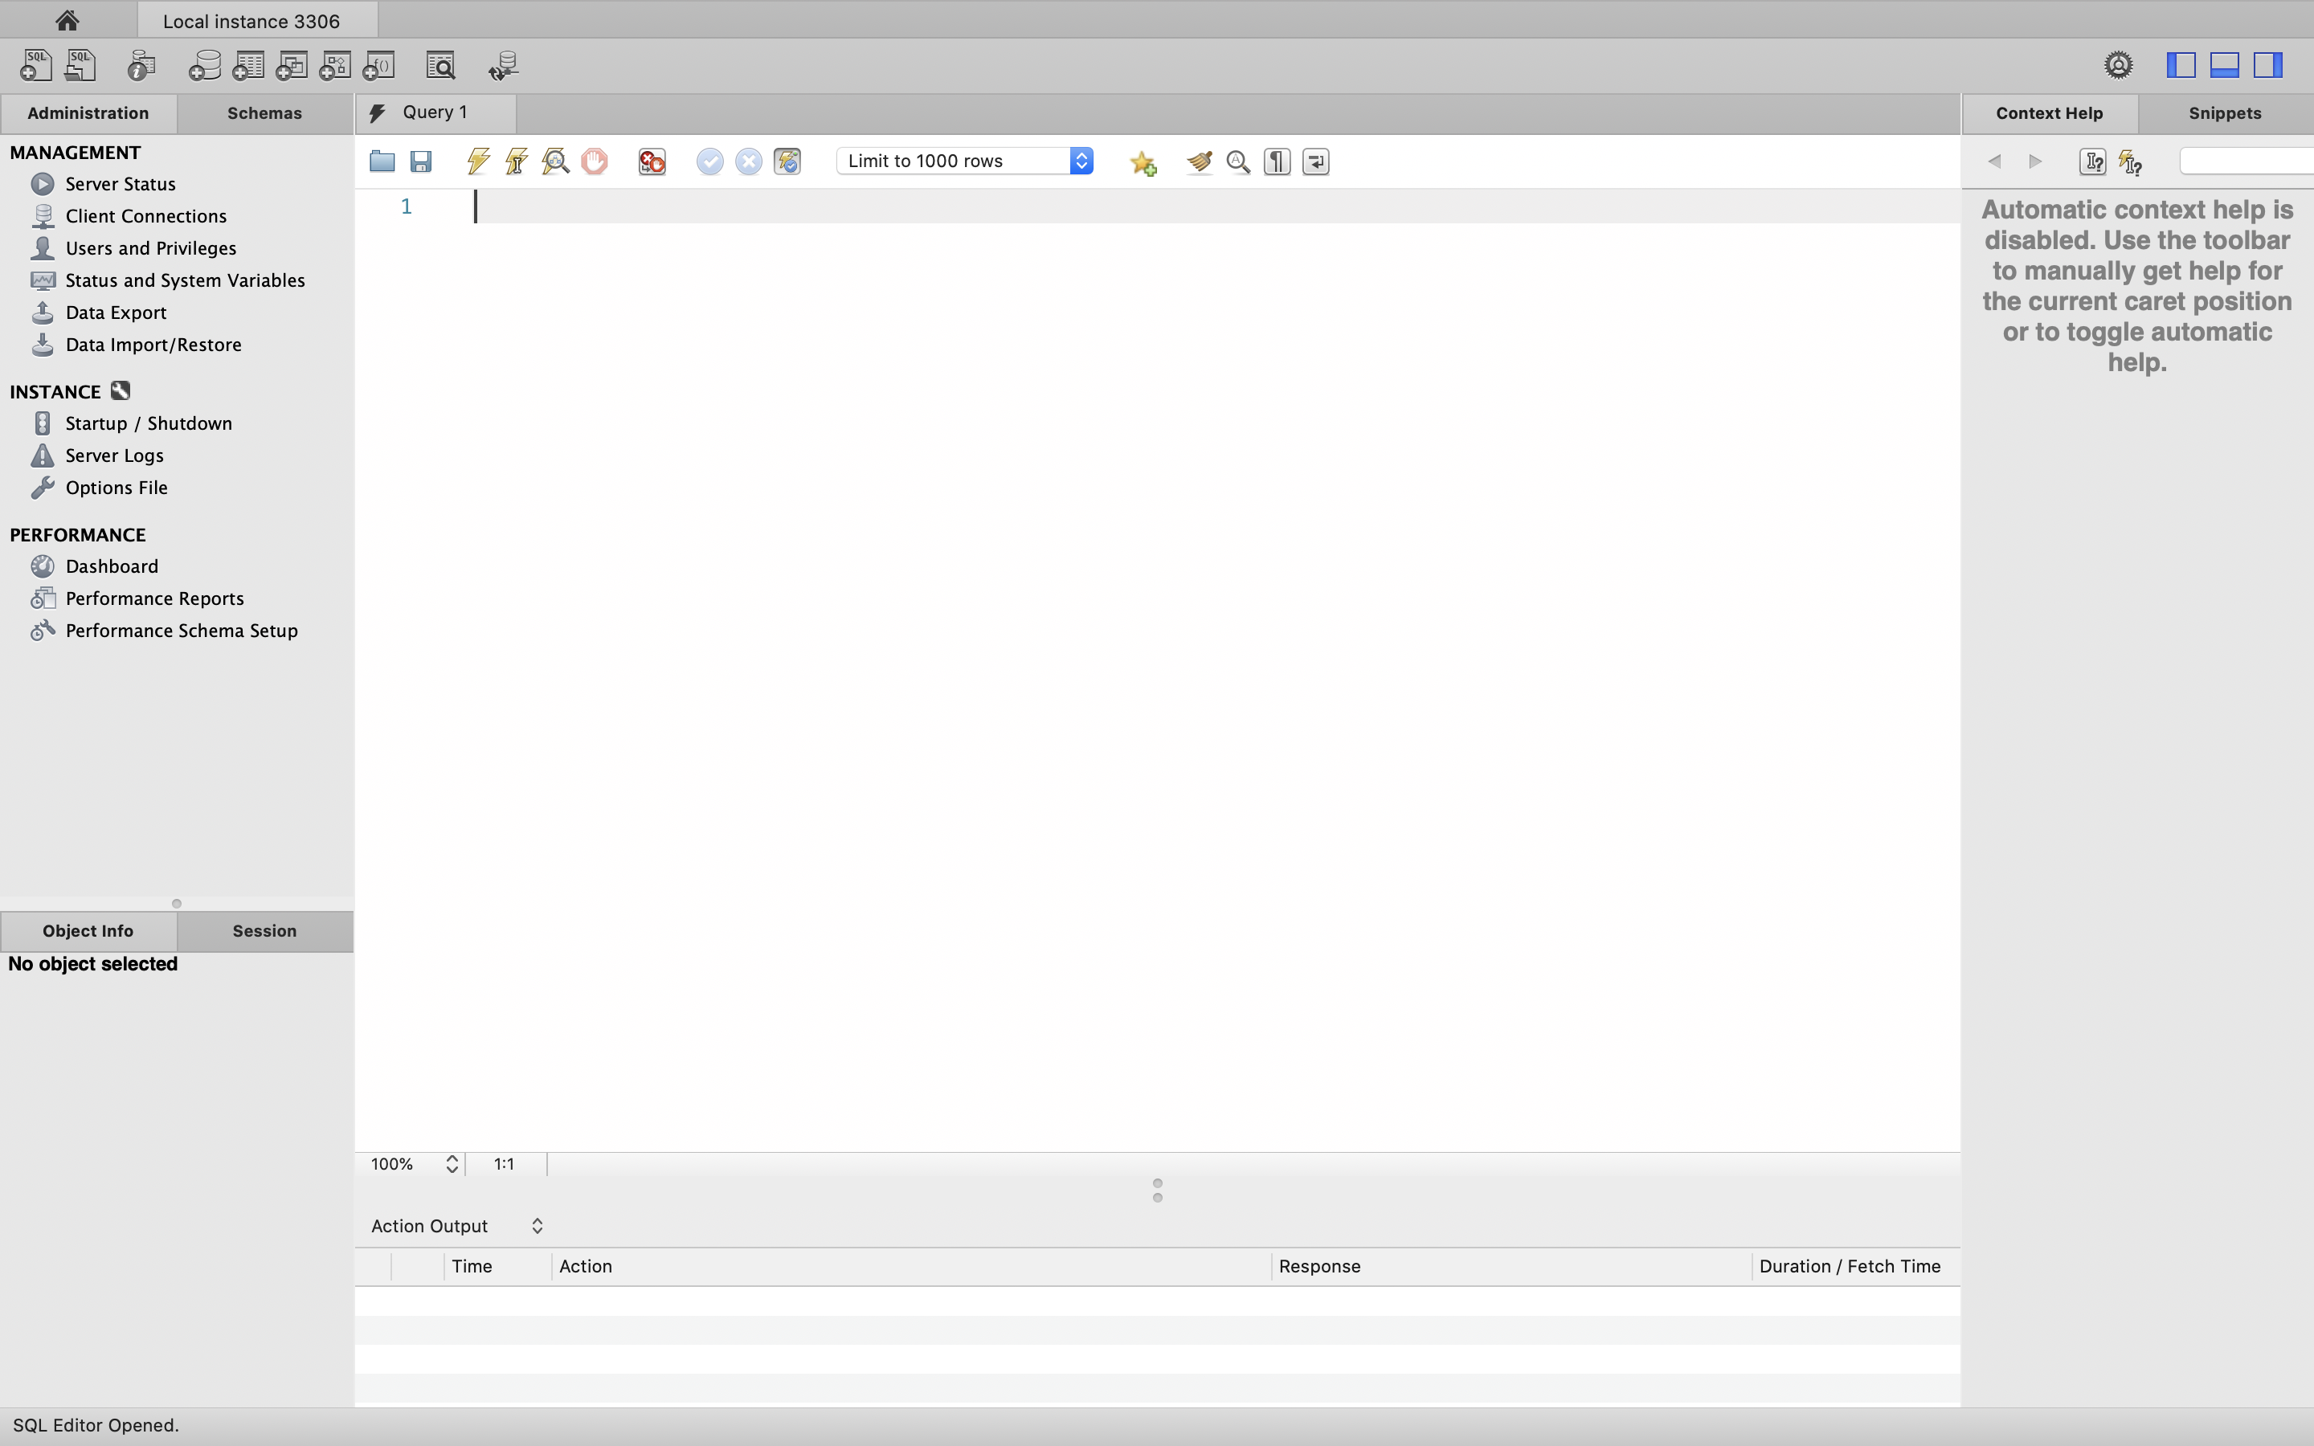

The above screenshot represents the interface of MySQL Workbench. Left tab shows all the available schemas, on the main screen there is query editor and below that we have the output tab. By clicking on , we can create new schemas.

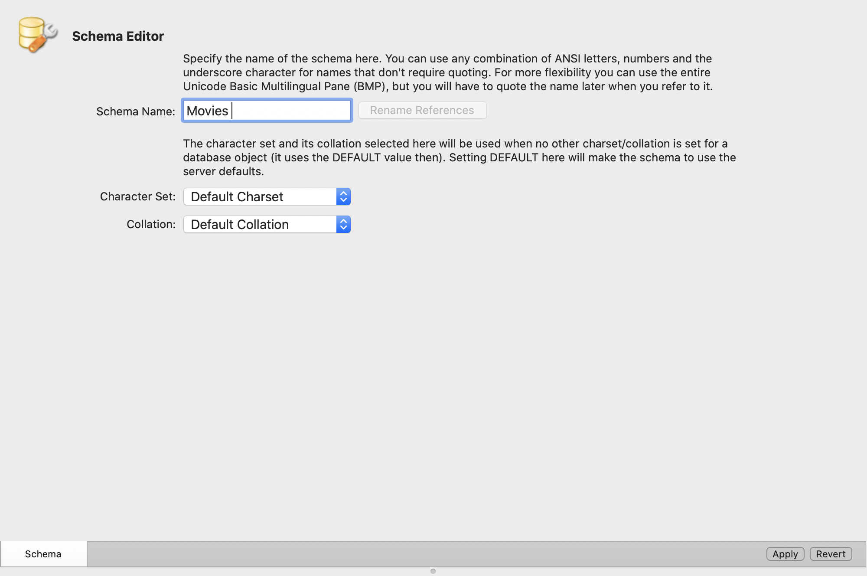

Here, we named our new schema as “Movies” and now we will create a new table by right clicking on the Table section below Movies schema on the left tab.

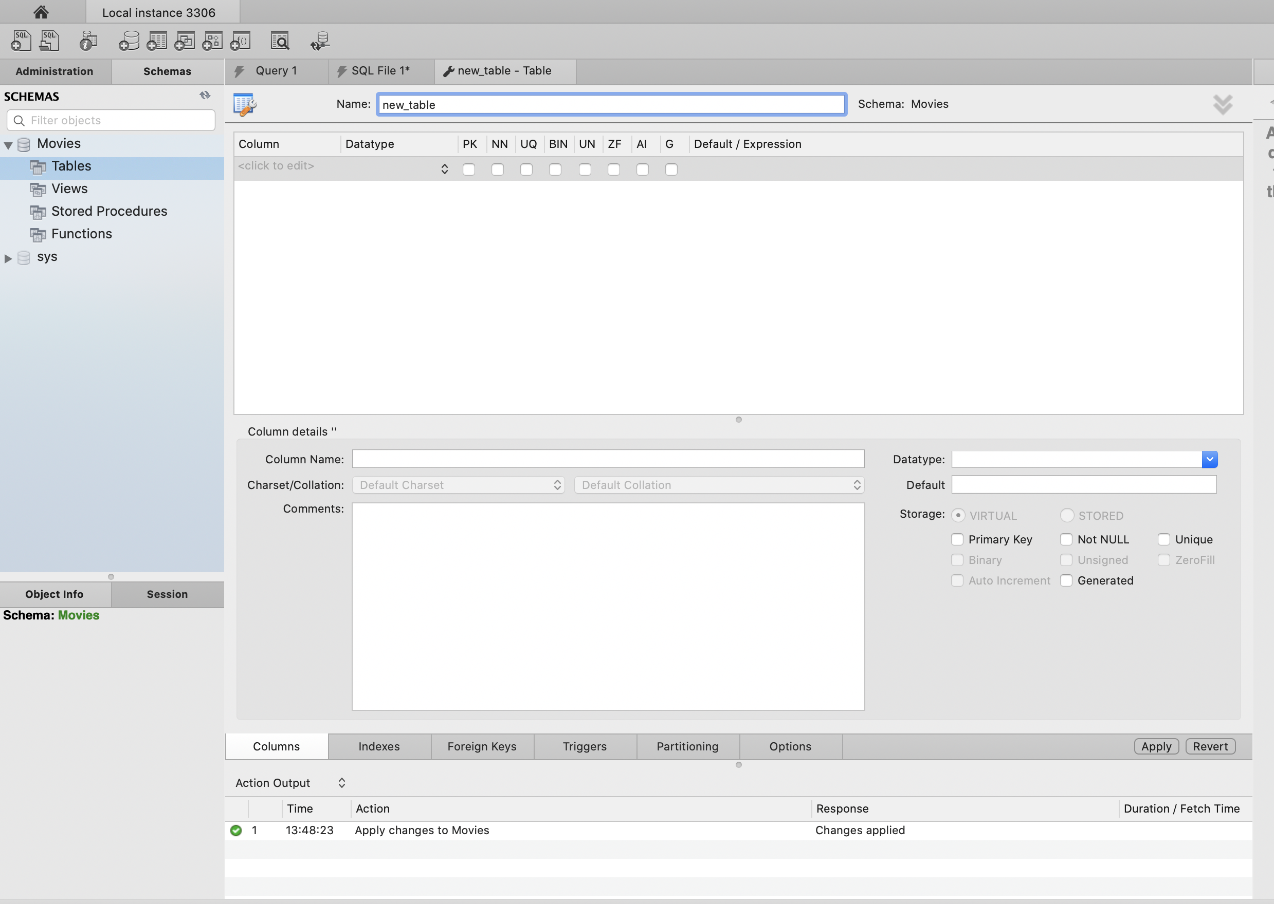

We will name this table as “new_table” only and we will start adding all the columns as per our dataset. After adding all the columns one by one, I have assigned Primary Key to the Title column. All the columns will be reflected in the left tab of the screen as shown below,

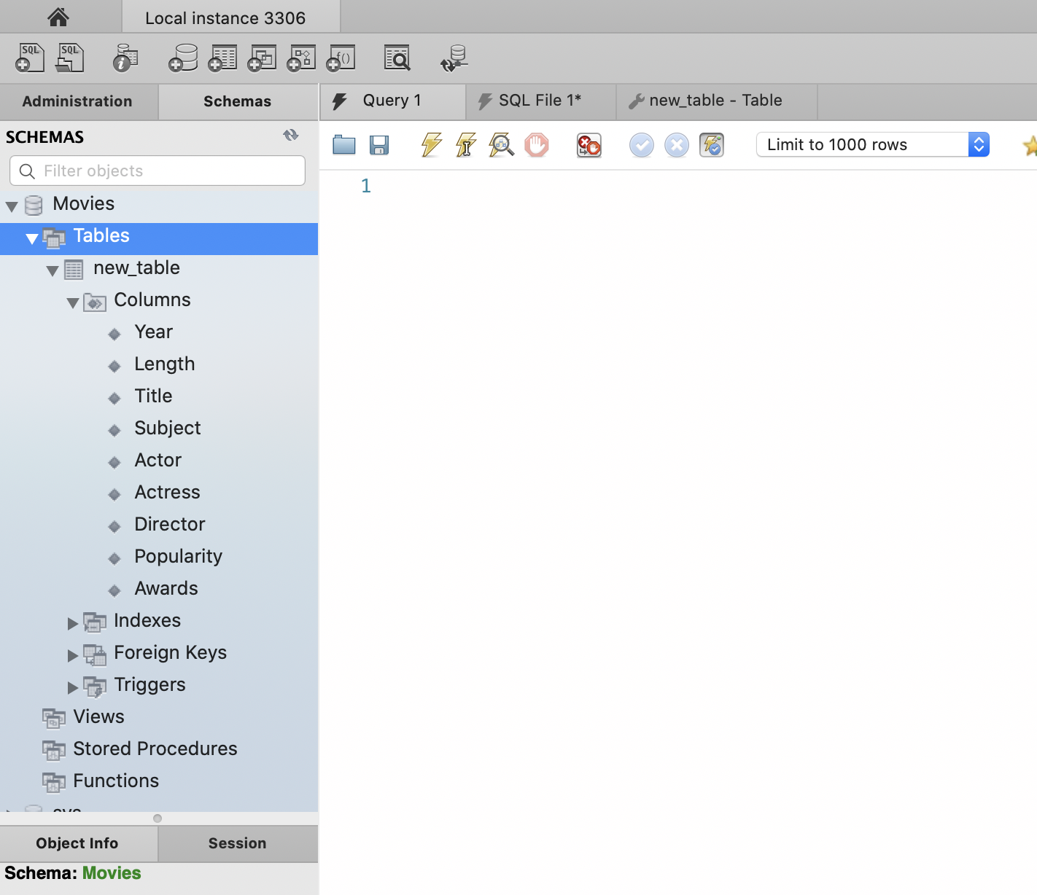

Now we will add path of our database to import the data to our new table. It can be done by clicking 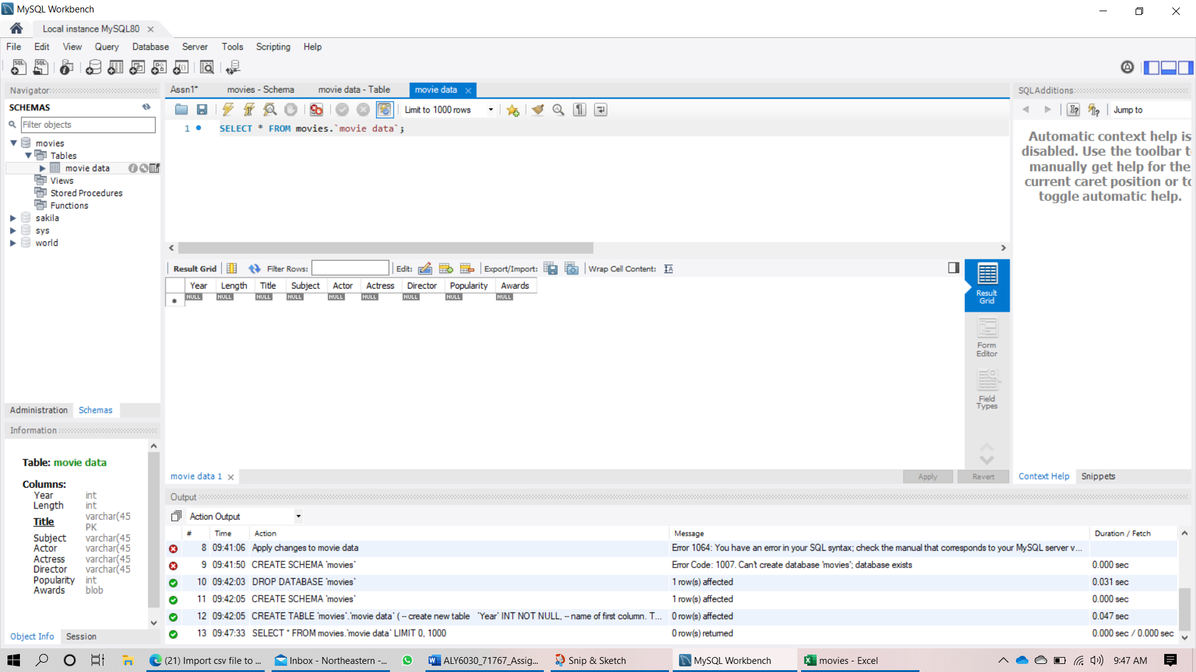 button right beside the ‘new_table’ and it will pop the screen as shown below,

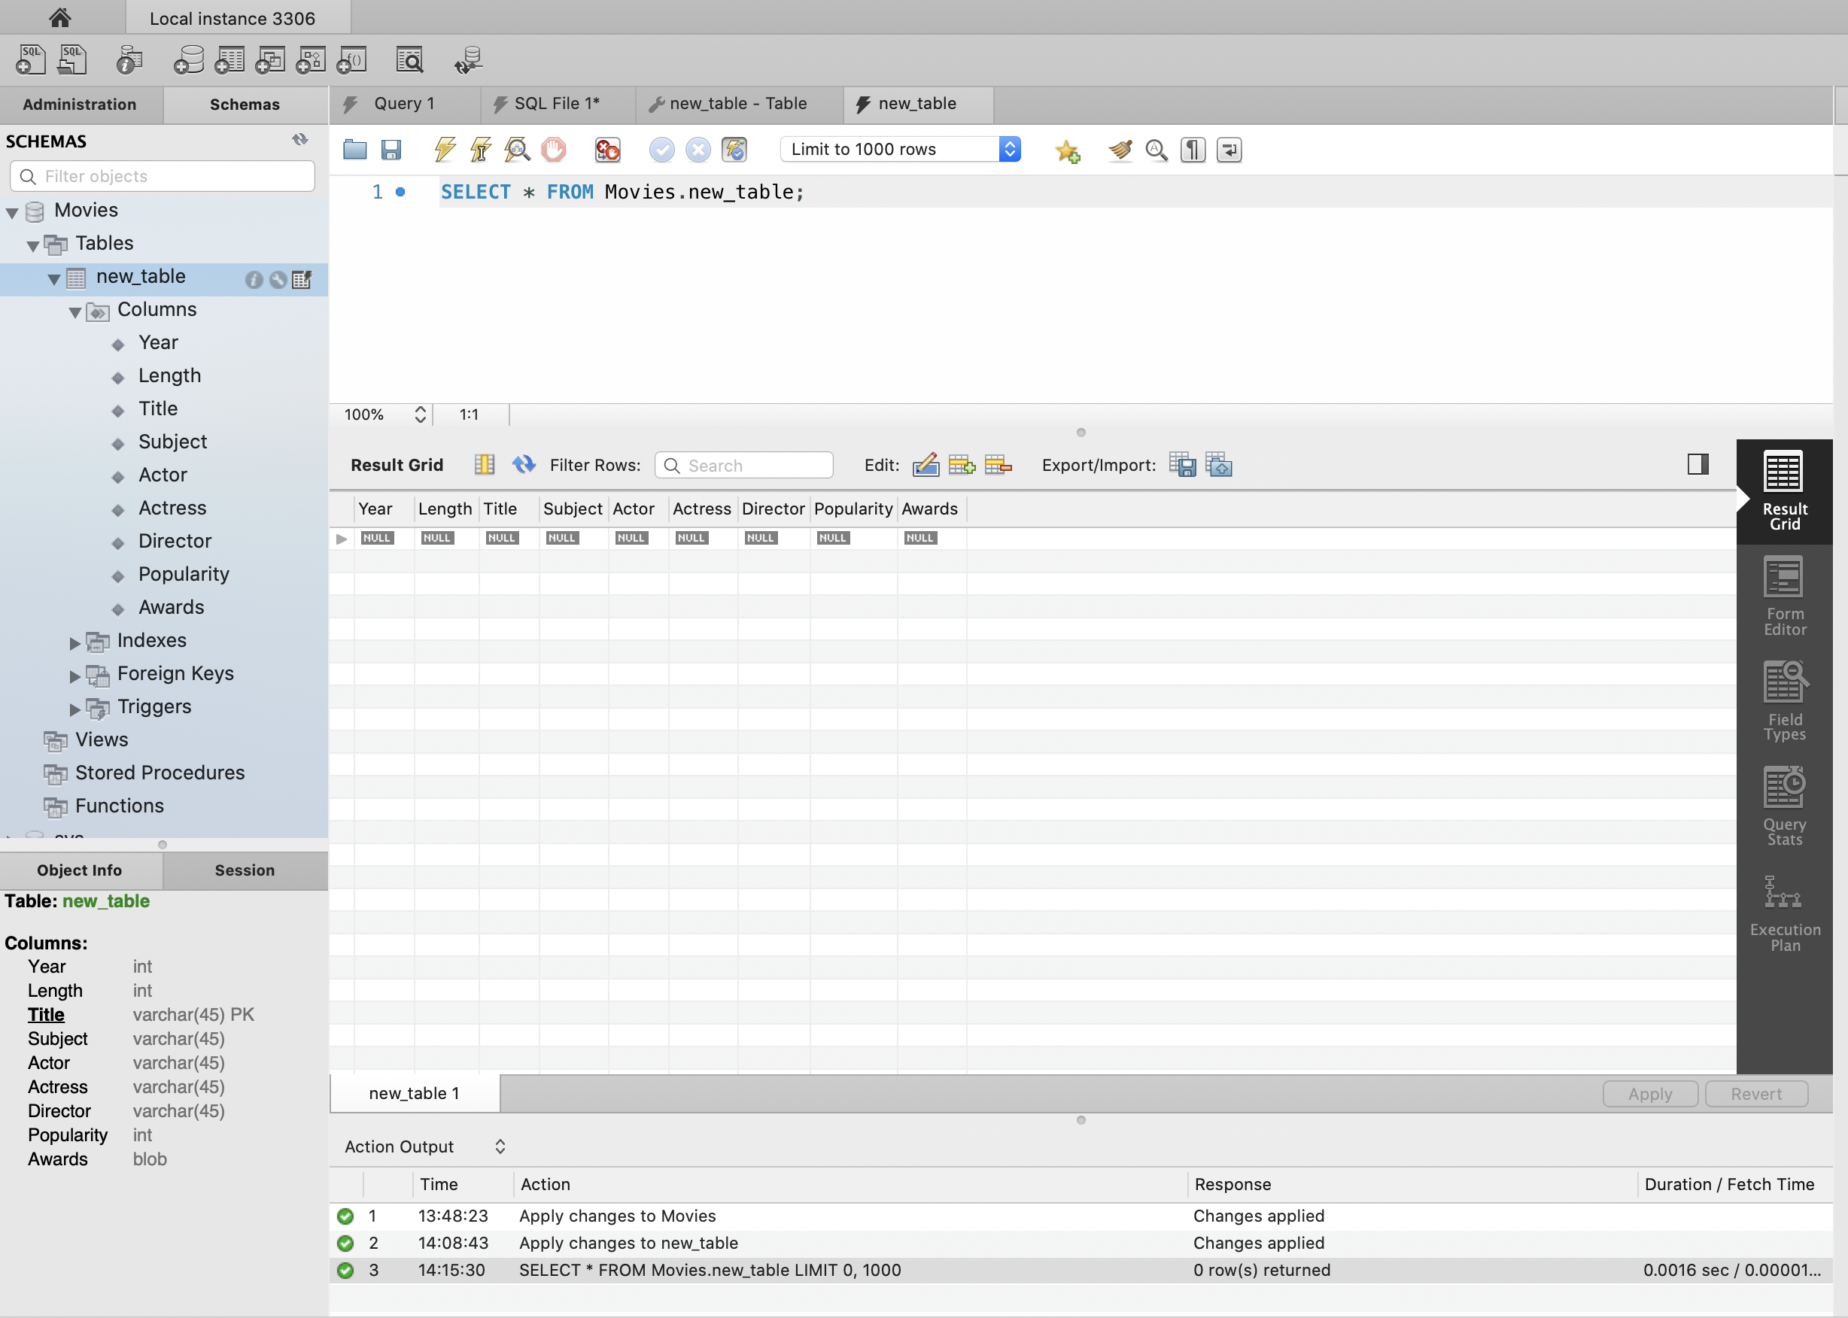

Now right click on the ‘new_table’ and select ‘Table data import wizard’ from the drop-down options. It will ask you to set the path of your .csv file.

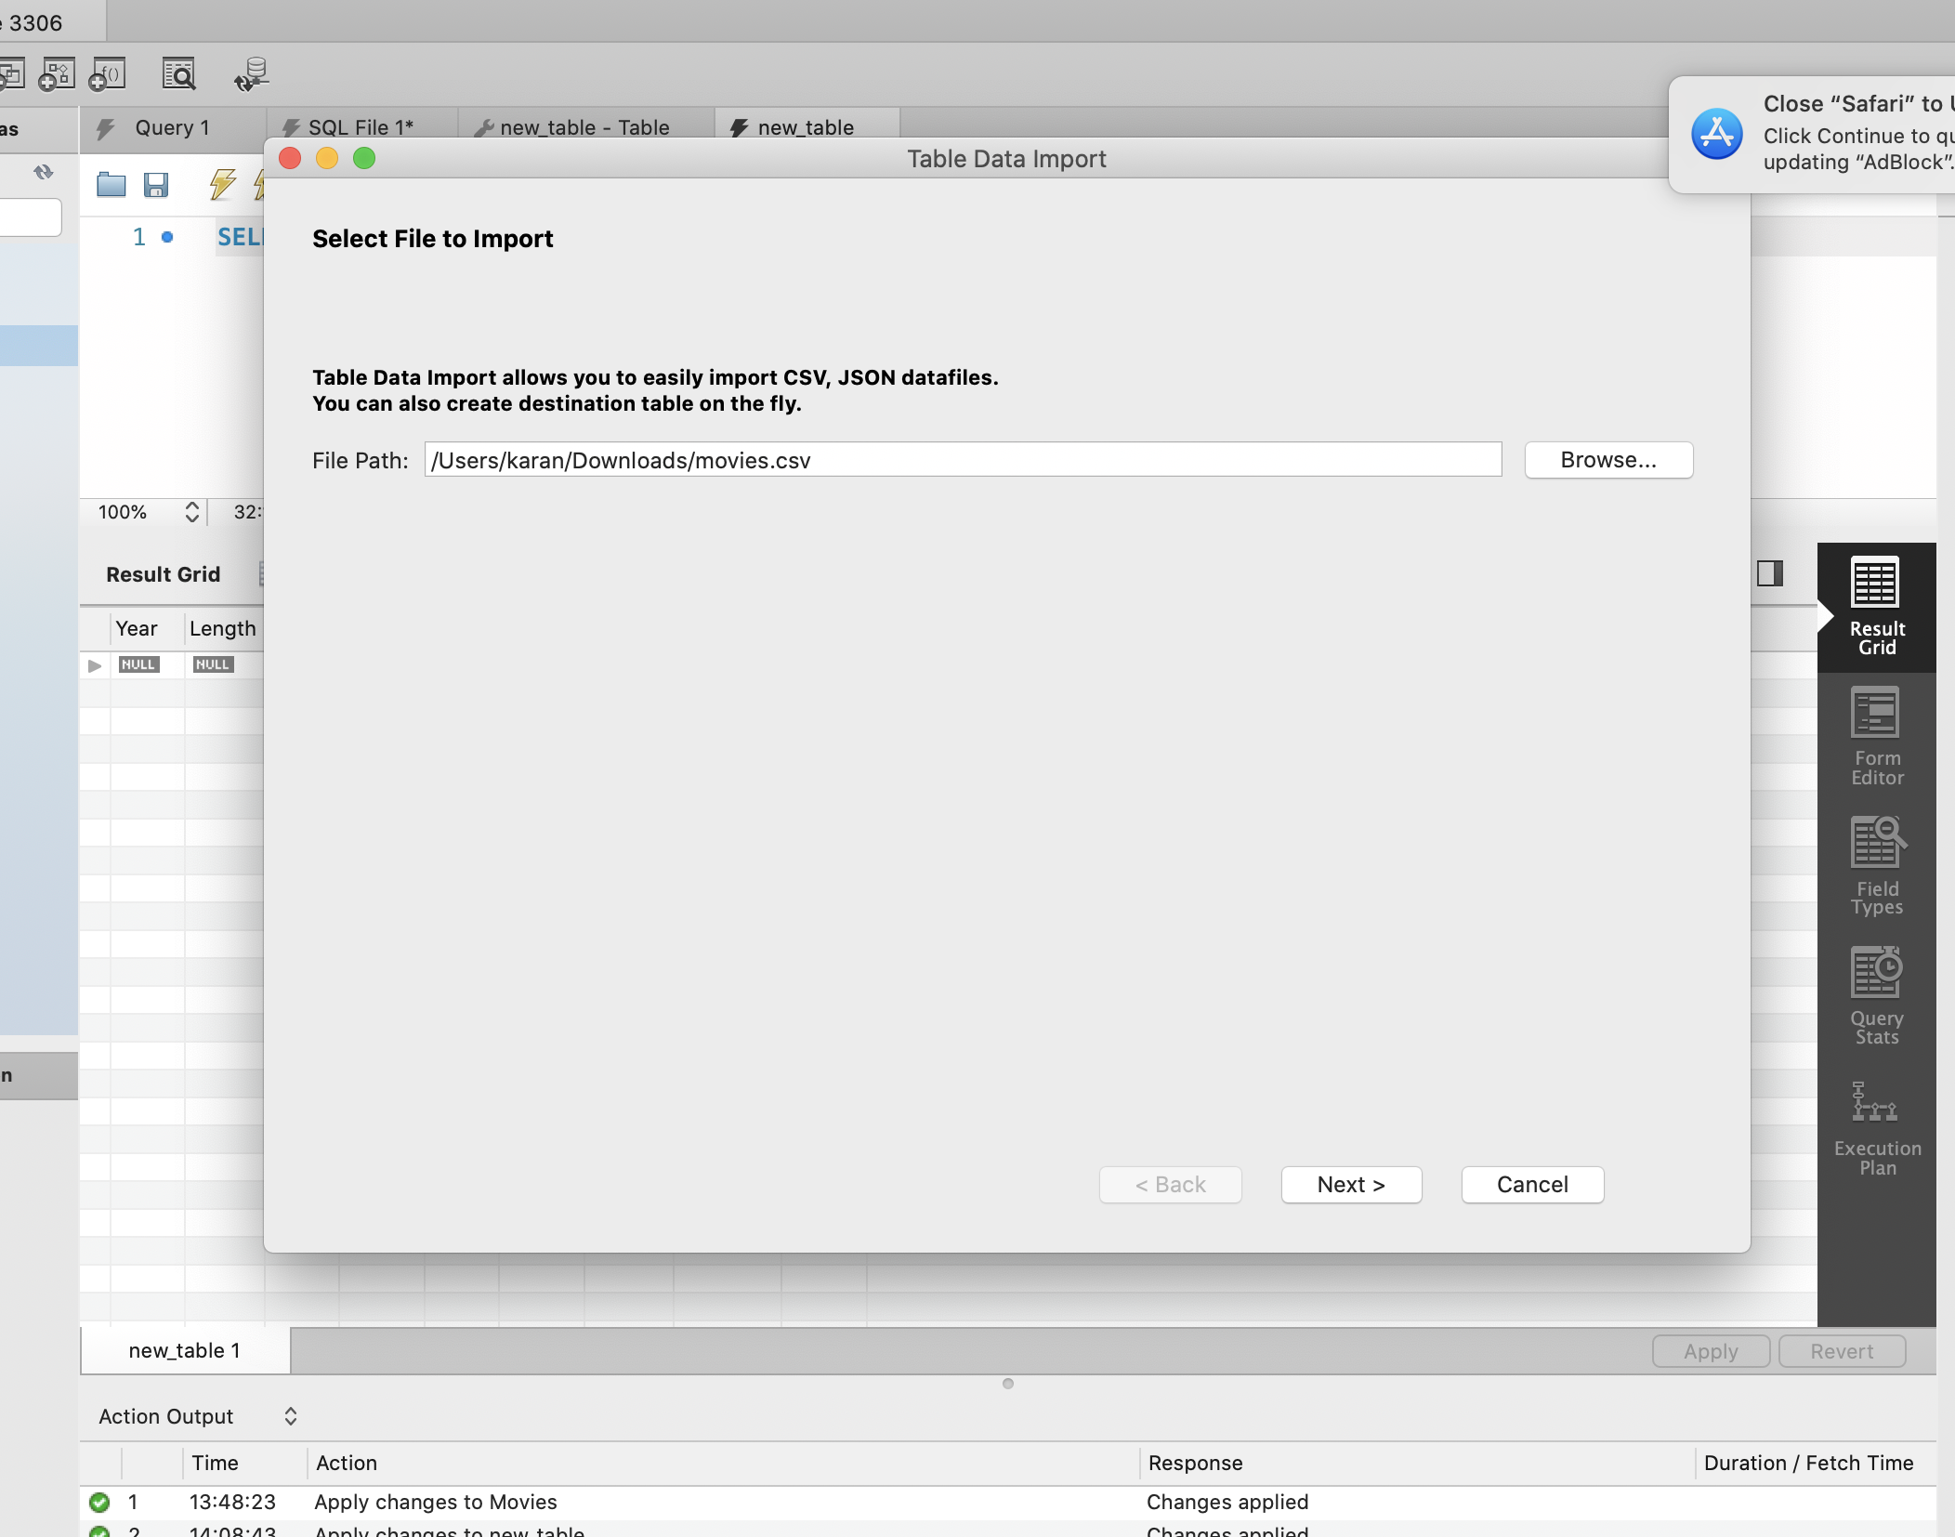

After clicking Next, choose the ‘cp1250’ encoding format which works perfectly fine for me. By default, it was selected utf-8.

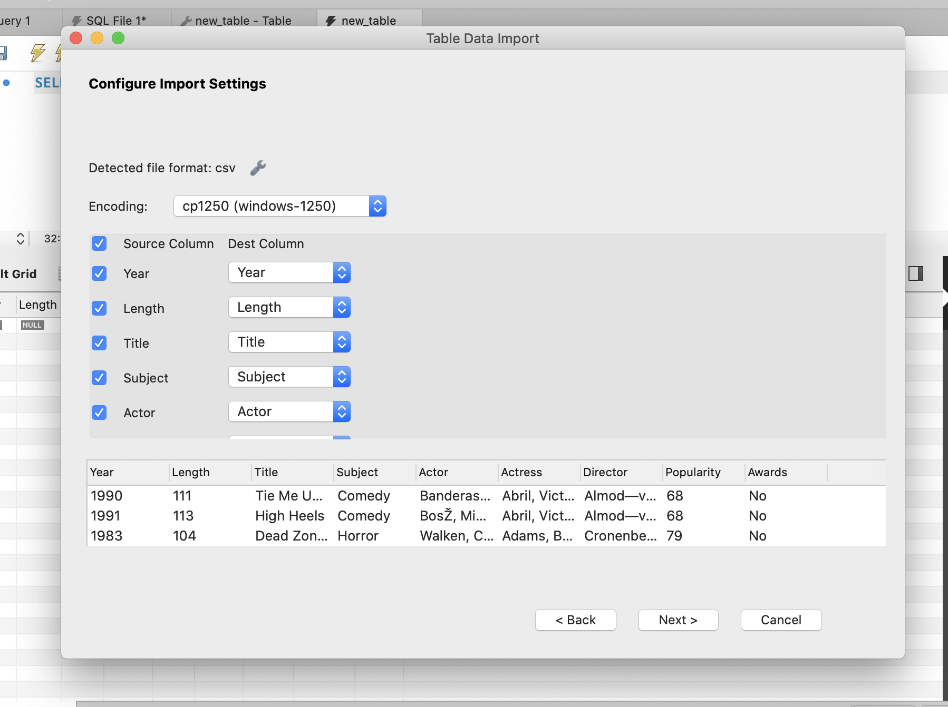

After finishing the above step successfully, you can refresh and check that everything is reflected properly like below given screenshot.

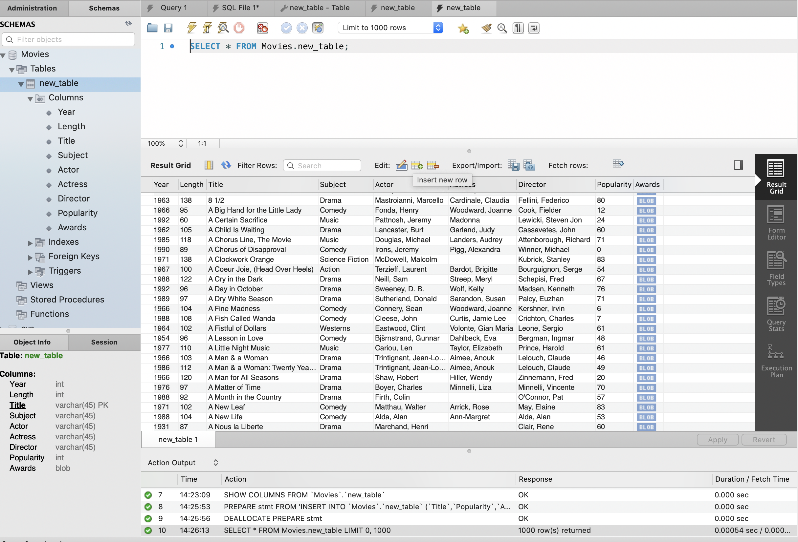

Now, our database is ready to answer the questions.

**Question 1:** Show only ‘Awarded comedy movies’ from the schema and arrange the results according to their popularity.

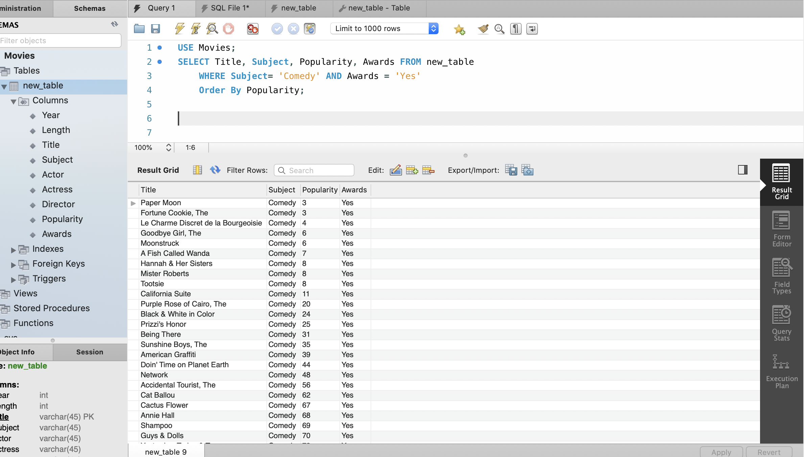

**Query:**

USE Movies;

SELECT Title, Subject, Popularity, Awards FROM new_table

WHERE Subject= 'Comedy' AND Awards = 'Yes'

Order By Popularity;

**Question 2:** Which are the least famous movies in your schema?

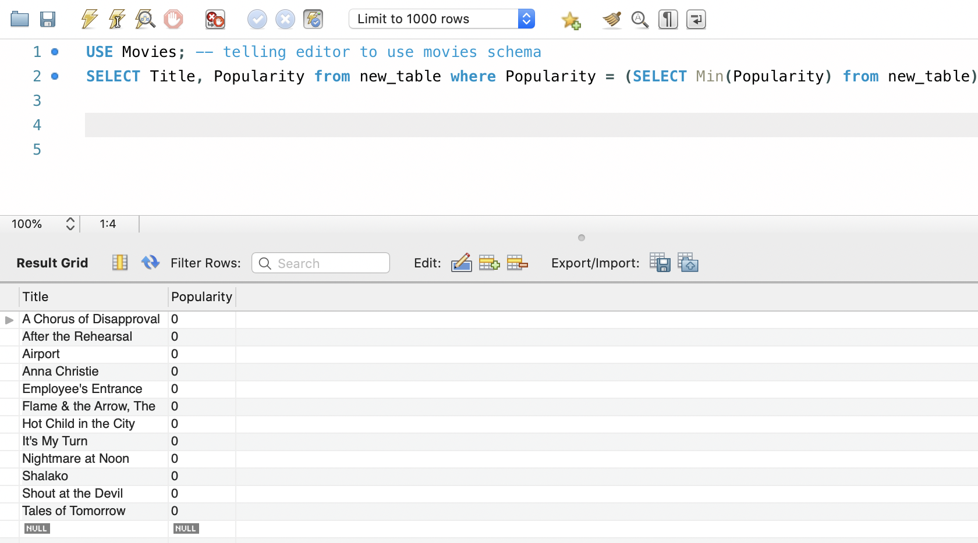

**Query:**

SELECT Title, Popularity from new_table where Popularity = (SELECT Min(Popularity) from new_table)

By using the above command, we get 12 least famous movies from our database (schema).

**Question 3**: Display all the movies starring ‘John Wayne’.

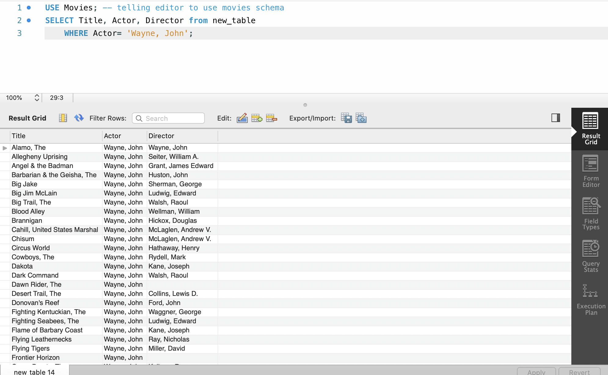

**Query:**

SELECT Title, Actor, Director from new_table

WHERE Actor= 'Wayne, John';

Here we can see all the movies of John Wayne and their Directors too.

Conclusion:

The features of MySQL include robust transactional support, ease of management, high performance, low cost ownership, 24/7 support, secure data protection and many more. The pros of using MySQL are Data Security, on-demand scalability, steady workflow control, open source flexibility, fast, portable and secure. Some of the cons are some stability issues, inefficient handling of transactions and functionalities are very heavily dependent on the add-ons. From this assignment, we got the basic knowledge of Sequel or SQL queries.